**Steps for Setting up Iot Device with Bluemix**

**Device Registration**

* Login to Bluemix platform on [https://console.ng.bluemix.net](https://console.ng.bluemix.net/) or create your account if you don’t have it.
* After Login, Click on Catalog and see all the available services and apps.

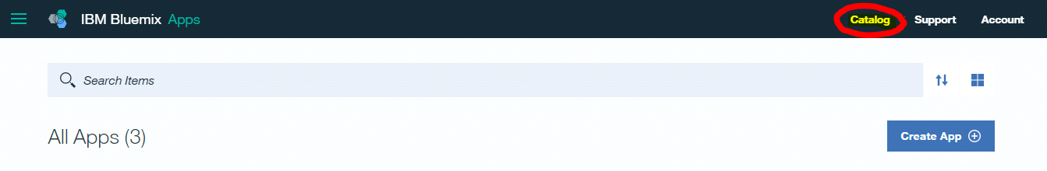

* Select “Boilerplates” and click on “Internet of Things Platform”.

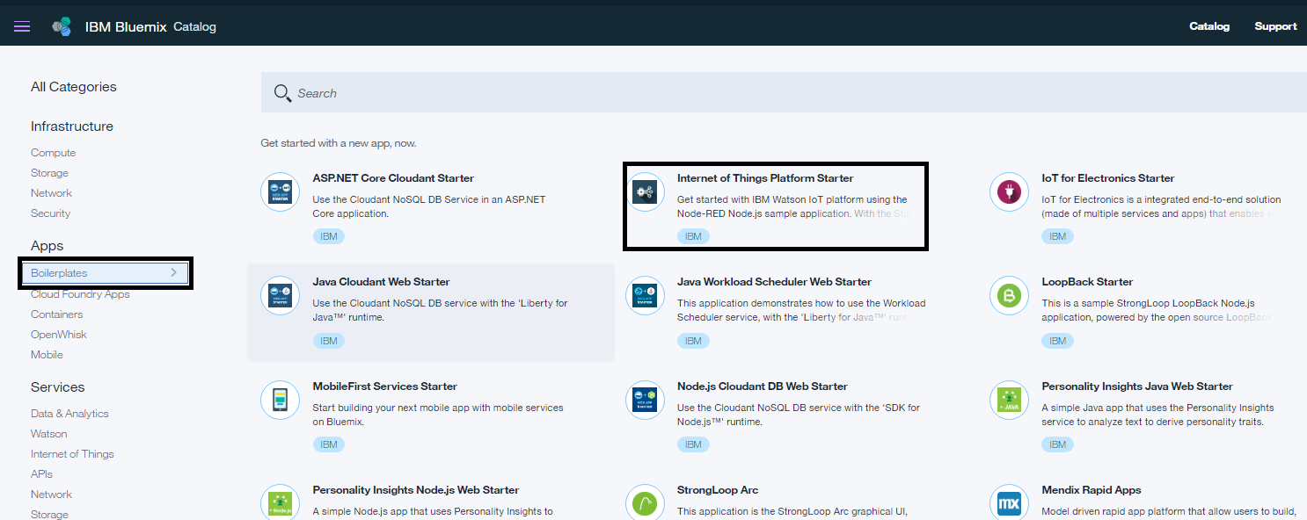

* Provide name to your application (Should be unique) and Goto dashboard click on service(Internet of things-IOTF). It will be your broker and we will be sending and receiving messages from here only.

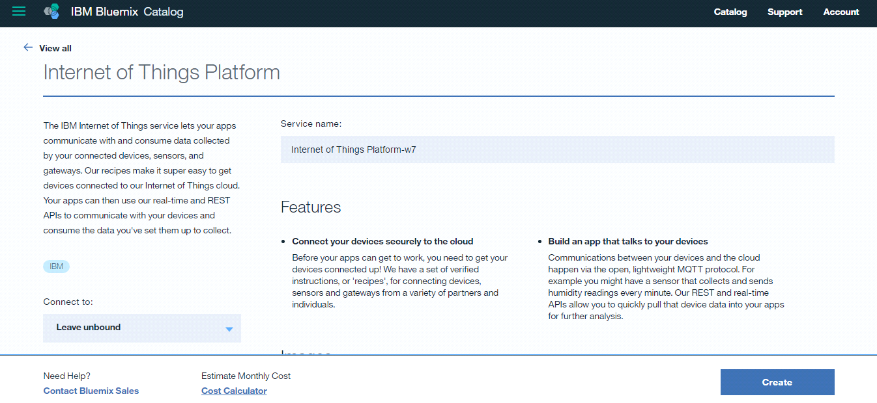

* Now you can see the service available on your dashboard. Click on your Internet of Things Platform service you just created and then click on “Launch” under “Manage” tab to see your IoT Dashboard.

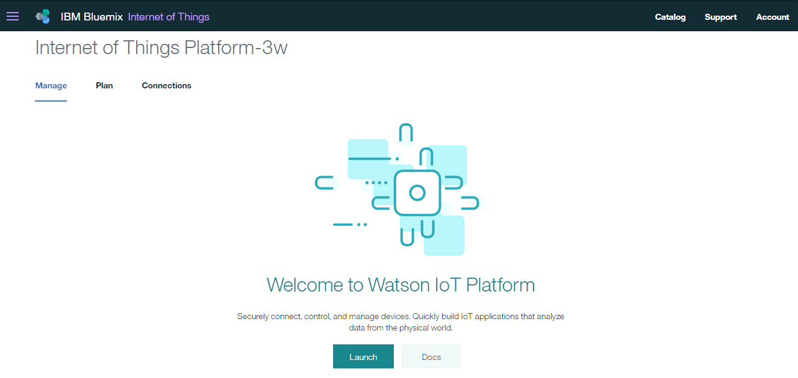

* From the left menu, click on devices.

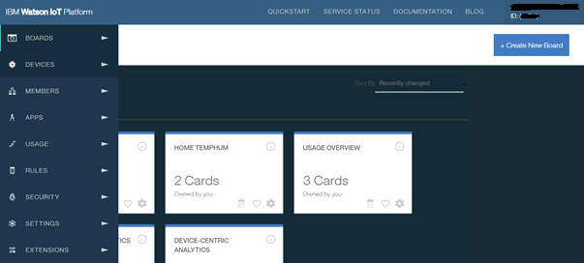

* Click on “Add Device” to create a new Device.
* Create the “Device Type” if not already created.
* Provide all the necessary information like name, description etc.
* Provide “Device Id” and click on next.
* Metadata is optional.
* For Setting up authentication, you can provide your own authentication token but if you don’t provide any then system will automatically generate a token for you.
* Review your device information and click on “Add” to create the device.
* Save the Authentication token as you will not able to find that anywhere else and it’s also need to be provided at the device side code.
* Click on Apps from left menu to generate your API Keys.
* Click on “Generate API Key” and Note down your API Key and authentication token, set your expiry date and then click on “Generate”.
* Make note of API Key and its token, it will be required for connecting to bluemix.

**Running Simulator**

* Now publish an event from your device. //Add github url for java publisher code
* After publishing event go the “Devices” and click on your device you will find your event data under “Recent Events”.

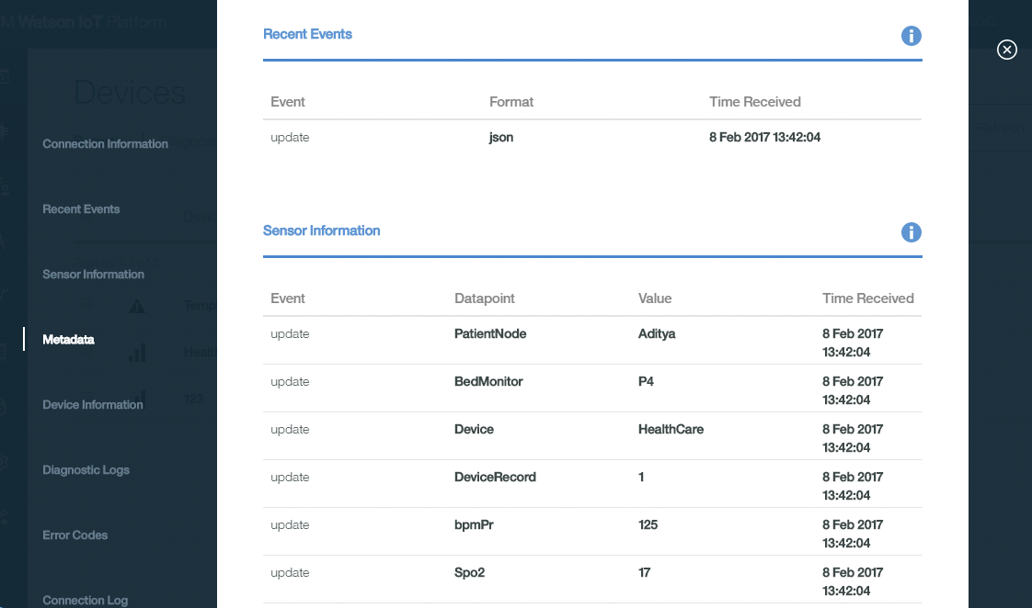

* Scroll down to see your connection log.

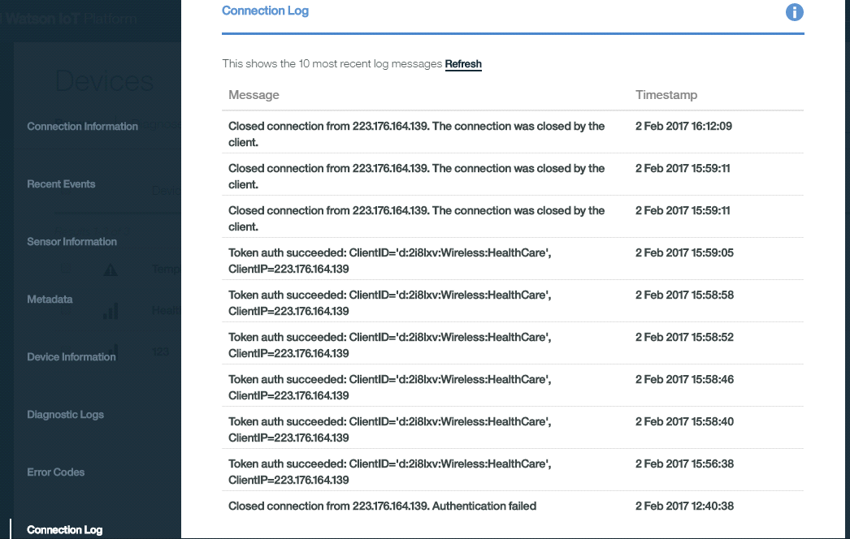

* Create a subscriber which will receive the messages from bluemix Iot platform and analyzes whether the threshold is breached or not. If breached sends a command to the alarm generating device.

NOTE: Subscriber code is uploaded on github (URL //Add github url).

* Steps to configure the alert device (In this case we are using intel Edison board)

Things Required

- Edison Board

- USB Data Cable

- Free USB port on your PC

Connect the Edison using a USB cable, connecting the micro USB port on second mini USB port from the edge. This USB port also provides power to the Edison, thus you will be able to have a power and Ethernet over the same connection. Once connected the Edison will power up and connect to your PC. Give the Edison a moment to connect to the PC. You should get a notification that a drive was mounted called Edison.

Network Adapter Settings

From your version of Windows view your Network Adapters (ie Network and Sharing > Change Adapter Settings) and look for a network adapter with the labelled RNDIS. If found, select properties to configure it's IP address. From the list select IPV4 and then click Properties and then click the Properties Button. Change the IP information as follows

IP: 192.168.2.2

Mask:255.255.255.0

**Device Alert**

* Download and setup Intel Edison Board Configuration Tool and connect to Wifi through it. //This exe is available at <http://software.intel.com/iot/hardware/edison/downloads>
* Nodejs is already installed in the Edison Board. Write the node js application to receive the command from bluemix Iot platform (Github Sample Code URL //).
* Connect Buzzer with Edison board (In the sample code it is connected to PIN no 3).
* Run your node application to receive the signal from subscriber application. As soon as it receives a command, buzzer will beep.

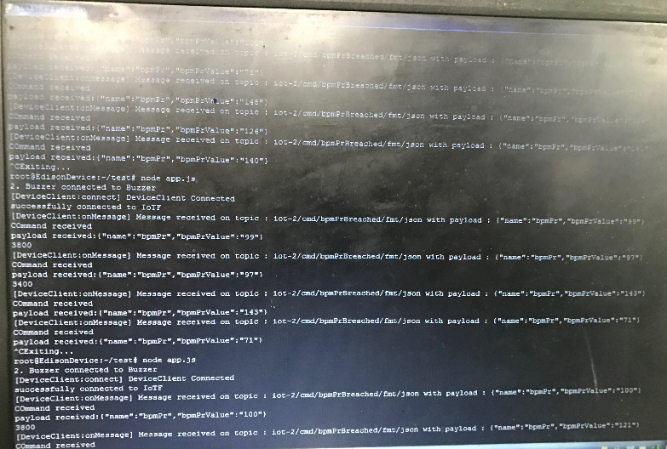

Snapshot of the device console recieving the data from the subscriber event

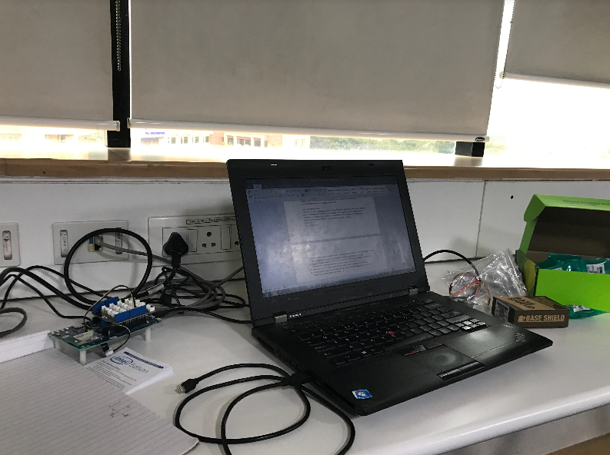

Intel Edison board